SIMATS ENGINEERING

CO3- AT2 - Design Task - Medium

COURSE NAME: Advance Wireless Communication Systems / 5G / 6G Communication Systems
COURSE CODE: ECA56

COURSE OUTCOME COVERED

CO: 3 - Design spectrum access strategies, waveform generation methods, and multiple access techniques for efficient wireless transmission systems. (BL6)

Assessment Tool Weightage: 35%

Short description about assessment: Students design a system / model based on given requirements to assess creativity and application skills.

Dr.

QUESTIONS: 1 (1 X 50 = 50) Total Marks: 50 Duration: 2hrs

- Propose a cloud-based wireless framework for smart surveillance systems. (BL6)

Code of Conduct:

I (Name / Reg No) certify that this submission is my original work and that I have adhered to the guidelines specified for this assessment. I understand that any violation of academic integrity rules will result in disciplinary action.

Signature of the student:

1. Aim
To propose a cloud-based wireless framework for smart surveillance systems that enables real-time monitoring, cloud storage, intelligent analysis, and remote access.
2. Objectives
- Real-time video and sensor monitoring.
- Wireless transmission using Wi-Fi/5G.
- Secure cloud storage of surveillance data.
- Intelligent detection of suspicious activities.
- Remote monitoring through mobile/web applications.
- Scalable and reliable surveillance infrastructure.
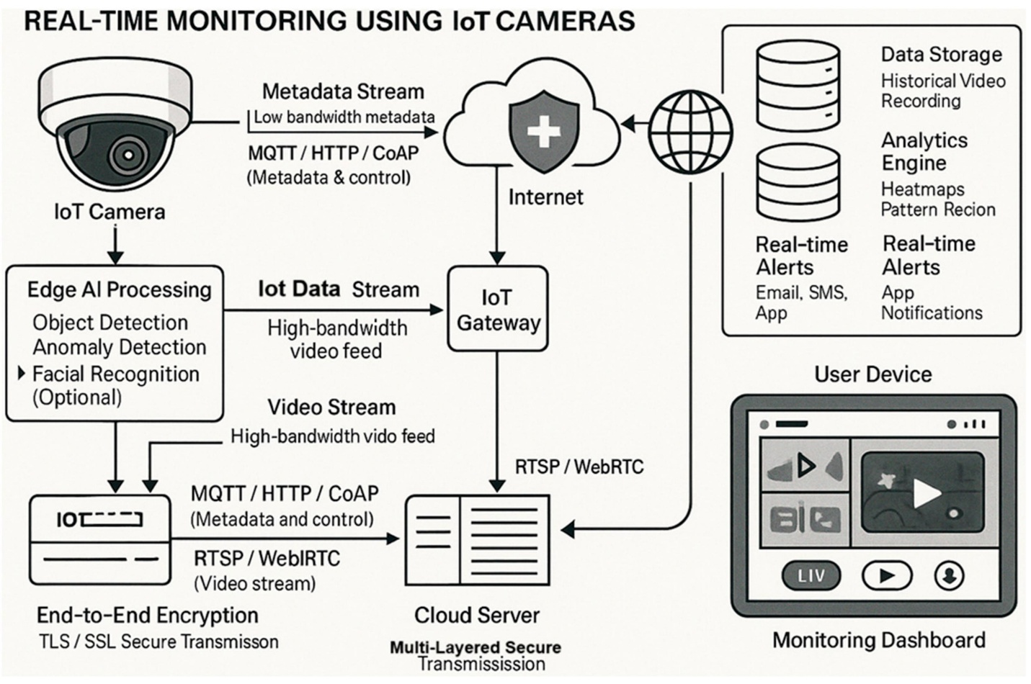

3. Proposed Cloud-Based Wireless Framework
Figure 1: Proposed cloud-based wireless smart surveillance architecture
The framework consists of surveillance cameras and IoT sensors, a wireless gateway, Wi-Fi/5G connectivity, cloud storage and processing, AI-based analytics, and a user monitoring application.

4. System Architecture

┌───────────────────────────────┐
│ SURVEILLANCE AREA │
│ │
│ IP Cameras IoT Sensors │
│ 📷 📷 📷 Motion/Sound │
└───────────────┬───────────────┘
│
Wi-Fi / 5G
│
▼
┌───────────────────────────────┐
│ WIRELESS GATEWAY │
│ Data Collection & Filtering │
└───────────────┬───────────────┘
│
Secure Internet
│
▼
┌───────────────────────────────┐
│ CLOUD PLATFORM │
│ │
│ ┌─────────┐ ┌────────────┐ │
│ │ Storage │ │ AI/Video │ │
│ │ │ │ Analytics │ │
│ └─────────┘ └────────────┘ │
│ │ │
│ Alert Generation │
└──────────────┬────────────────┘
│
▼
┌───────────────────────────────┐
│ USER APPLICATION │
│ Mobile / Web Dashboard │
│ Live Video + Alerts │
└───────────────────────────────┘

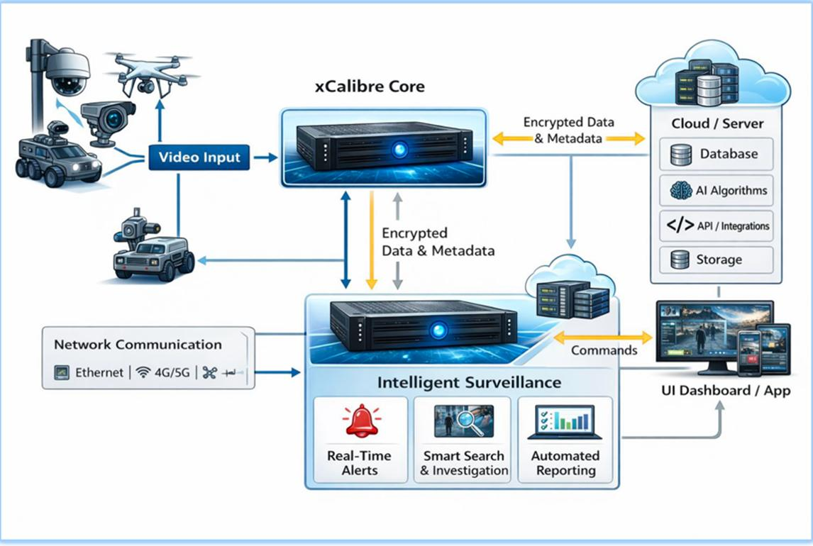

5. Working Principle
Figure 2: Wireless surveillance data flow
- Cameras capture live video from the surveillance area.
- IoT sensors detect motion and other events.
- Data is transmitted wirelessly through Wi-Fi/5G.
- The wireless gateway collects and forwards the data.
- The cloud platform stores the received surveillance information.
- Cloud AI analyzes video and sensor information.
- Suspicious activity generates an alert.
- The alert is sent to the authorized user.
- The user can view live or recorded video remotely.

6. Cloud Data Processing

Camera/Sensor → Wireless Gateway → Internet → Cloud → AI Analysis → Storage → Alert → User
Figure 3: Cloud processing and intelligent surveillance

7. Major Components
Component | Function
IP Camera | Captures surveillance video
IoT Sensors | Detect motion/events
Wi-Fi/5G | Wireless communication
Gateway | Collects and forwards data
Cloud Storage | Stores video/data
Cloud AI | Detects suspicious activities
Mobile/Web App | Remote monitoring
Alert System | Sends event notifications

8. Security
Figure 4: Security layer for cloud surveillance
The proposed system should use:
- Data encryption.
- Secure wireless communication.
- User authentication.
- Role-based access control.
- Secure cloud storage.
- Regular firmware/software updates.
- Backup of important surveillance data.

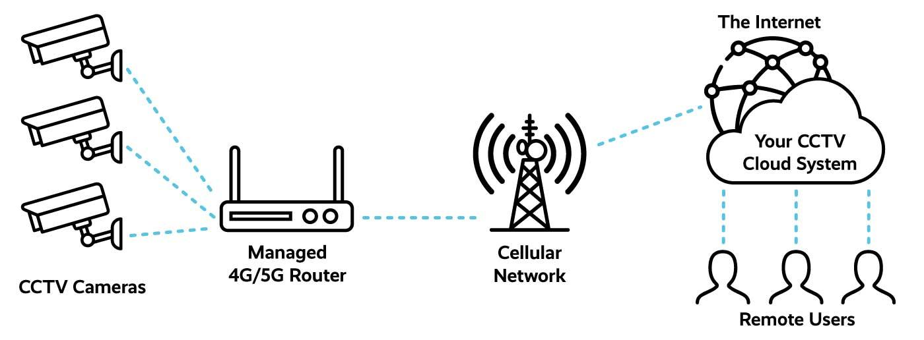

9. Evaluation of the Design
Strengths
- Remote access from anywhere.
- Large and scalable cloud storage.
- Centralized surveillance management.
- Supports AI-based detection.
- Suitable for large surveillance areas.
- 5G can support high-speed wireless video transmission.

Weaknesses
- Requires reliable Internet connectivity.
- Continuous video transmission requires high bandwidth.
- Cloud services introduce operating costs.
- Privacy and cybersecurity are important concerns.
The evaluation component is particularly important because your rubric awards 25% for evaluation, requiring identification of strengths, weaknesses, and design gaps.

- Proposed Improvement – Edge + Cloud

Figure 5: Improved edge-cloud surveillance framework
Instead of sending every video frame to the cloud, an edge gateway can perform initial AI processing near the camera.

Camera
↓
Edge Gateway
↓
Local AI Detection
↓
Suspicious Event?
↙ ↘
No Yes
↓ ↓
Filter Send Video
↓
Cloud
↓
Alert
↓
User

11. Applications
- Smart cities
- College campuses
- Banks and ATMs
- Industrial areas
- Shopping malls
- Traffic surveillance
- Residential security
- Public places

12. Conclusion
The proposed cloud-based wireless framework integrates IP cameras, IoT sensors, Wi-Fi/5G communication, cloud storage, AI analytics, and remote user applications. It provides scalable and intelligent surveillance with centralized data management. The addition of edge processing further improves the framework by reducing unnecessary cloud traffic and enabling faster event detection.

RUBRICS FOR CALCULATION:

Design Task
Criteria | Weightag e | Level 4 (Exemplary) | Level 3 (Proficient) | Level 2 (Developing) | Level 1 (Beginning)
Understanding of Design | 20% | Demonstrates deep understanding of design objectives, constraints, and context | Shows good understanding with minor gaps | Partial understanding; misses key aspects | Lacks understandin g of the design context
Evaluation of Design | 25% | Provides in-depth critique identifying strengths,  weaknesses, and design gaps | Identifies key issues with reasonable analysis | Limited critique; mostly descriptive feedback | No meaningful critique provided
Justification | 20% | Supports critique with strong reasoning, evidence, and relevant principles | Provides justification with some supporting evidence | Weak or unclear justification | No justification for feedback
Suggestions for Improvement | 20% | Offers innovative, practical, and well-justified improvement suggestions | Provides useful suggestions with minor gaps | Suggestions are limited or partially relevant | No constructive suggestions provided
Communicatio n | 15% | Communicates feedback clearly, professionally, and engages actively in discussion | Communicates well with minor issues | Communication lacks clarity or engagement | Poor communicati on and minimal participation

